9-1 Final Project Submission: Operating System Upgrade Implementation Report and Presentation

Christopher Gray

Department of Information Technology, Southern New Hampshire University

IT-505

Dr. Keith Washington

**Code: Components**

**Variables**

Variables in JavaScript are considered data containers since they may be used to store and manipulate data in a program (Mozilla Developer Network (MDN) Web Docs, n.d.). Variables in JavaScript can hold any kind of data, including numbers, texts, arrays, objects, and additional variable types, according to W3Schools (n.d.). The type of a variable may change dynamically throughout the course of a program since JavaScript is a loosely typed language (Mozilla Developer Network (MDN) Web Docs, n.d.).

**Data Structures**

Data structures in JavaScript are used to organize and store data in a way that permits efficient access and modification. There are a number of built-in data structures in JavaScript, such as arrays and objects, as well as a number of other data structures that may be created using third-party libraries (W3Schools, n.d.). In JavaScript, arrays are sorted lists of items that can include everything from numbers and texts to objects and more. Arrays are indexed from 0 and formed using square brackets (W3Schools, n.d.).

**Control Structures**

JavaScript uses control structures to regulate how a program runs based on circumstances or looping. Furthermore, If/else statements, for loops, and while loops are the three primary control structures used in JavaScript. If a specific condition is met, an if/else statement is used to run one piece of code; if it is not, a different block of code is executed. To repeat a block of code a certain number of times, the programmer uses a for loop. When a given condition is met, a while loop is used to repeat a block of code (W3Schools, n.d.)

**Syntax**

The guidelines that specify how the code should be articulated, including its structure and formatting, are referred to as the syntax of the programming language. JavaScript syntax integrates elements like variables, data types, operators, control structures, and functions and is influenced by other programming languages like C and Java (W3Schools, n.d.). Variables are declared in JavaScript by using the term ‘var’, ‘let’, or ‘const’, followed by the variable name. Strings, integers, booleans, and other data types are available in JavaScript. JavaScript uses operators to execute operations on variables, including arithmetic, comparison, and logical operations (W3Schools, n.d.).

**Tools**

When working with JavaScript, developers have access to a number of tools that help streamline and increase productivity. Text editors, programming environments, and libraries are a few of the frequently used JavaScript tools. For writing and editing code, text editors with user-friendly interfaces, such as Atom, or Sublime Text, are available. They frequently provide functions like syntax highlighting and code completion, which can speed up and improve the effectiveness of the programming process (Sublime Text, n.d.; Atom, n.d.). Developers have access to a variety of tools and packages that may be used to create complicated apps through development environments like Node.js, which enable them to create and run JavaScript applications on the server side (Node.js, n.d.). Libraries, similar to jQuery or React, offer pre-written code that programmers can utilize in their own projects, frequently offering solutions to frequent issues and enhancing their projects' usefulness (jQuery, n.d.; React, n.d.).

**Code: Modification**

In the initial line of the code (Line 7) that is used, the upgrade date is January 19,2015. This causes the JavaScript editor to show a negative (-) or past date of 2964 days in the past as today is February 11, 2023. Therefore, this default date must be modified to the desired date to achieve the required outcome for this milestone. While looking over the details, this milestone requires a date of at least 30 days using a future date for Group 1, their upgrade date will be modified to March 14, 2023, in line 7 of the code. Next, Group 2 is required to have an upgrade date that is 2 days after the initial upgrade date. So, the date for Group 2 will be modified to March 16, 2023, in Line 7. In addition to these dates Group 3 is required to have a future date of 5 days after the modified 30-day upgrade date, the date for this group will be modified to March 19, 2023. Group 4 is required to have an upgrade date of 8 days after the first upgrade date, their date will be modified to March 22, 2023. Lastly, Group 5 is required to have an upgrade date of 10 days after the future upgrade date, their upgrade date will be modified to March 24, 2023. For all of these upgrades to occur on time only Line 7of the code needs to be updated. These dates will be reflected in the screenshots below.

Default date of upgrade:

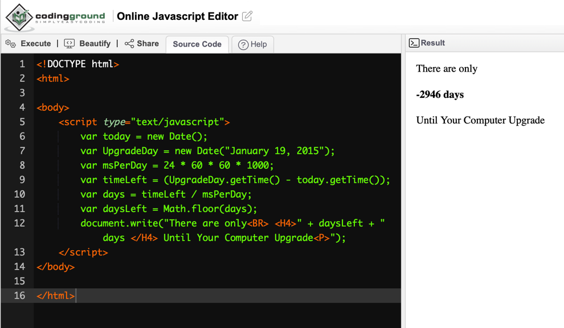

Group 1: requirement of at least 30 days into the future for initial date

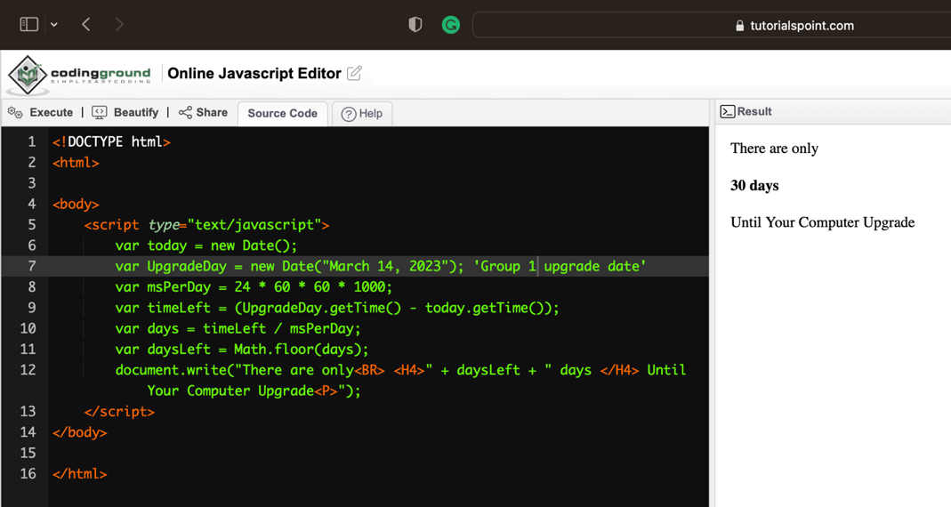

Group 2: 2 days after initial 30-day update

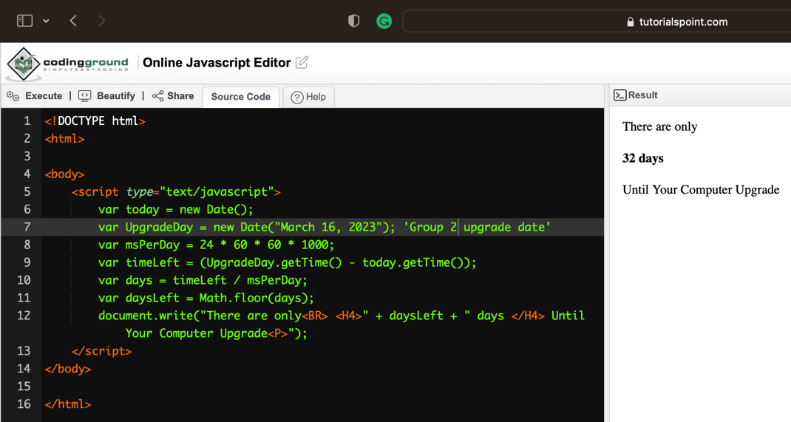

Group 3: 5 days after initial 30-day upgrade date

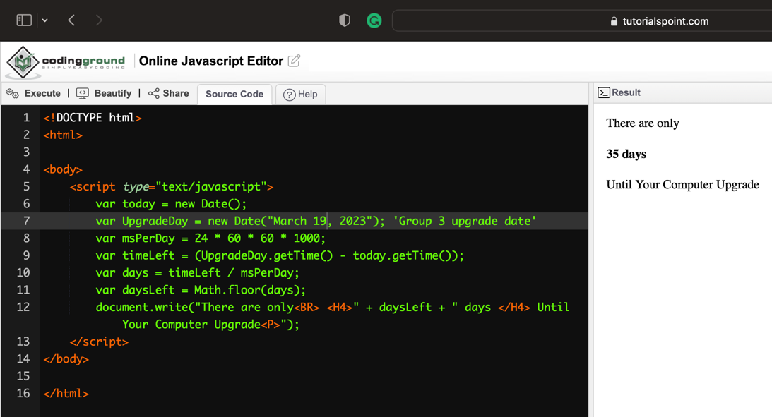

Group 4: 8 days after the initial upgrade date

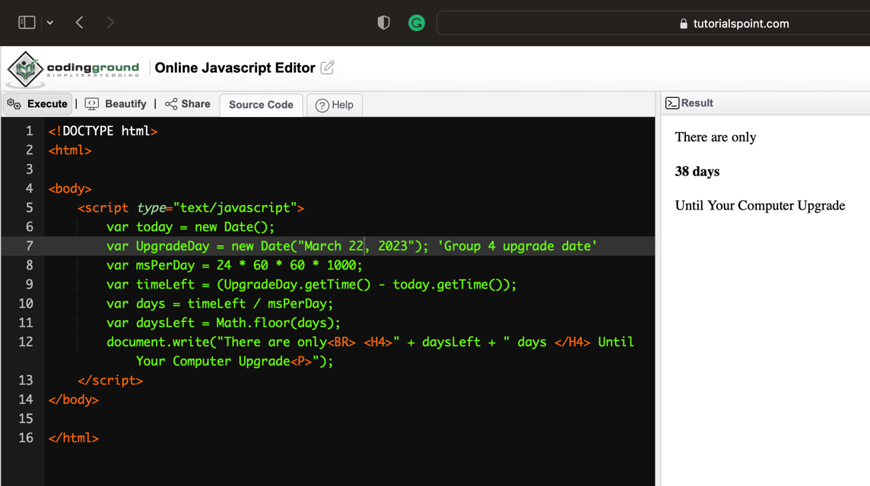

Group 5: 10 days after initial upgrade date

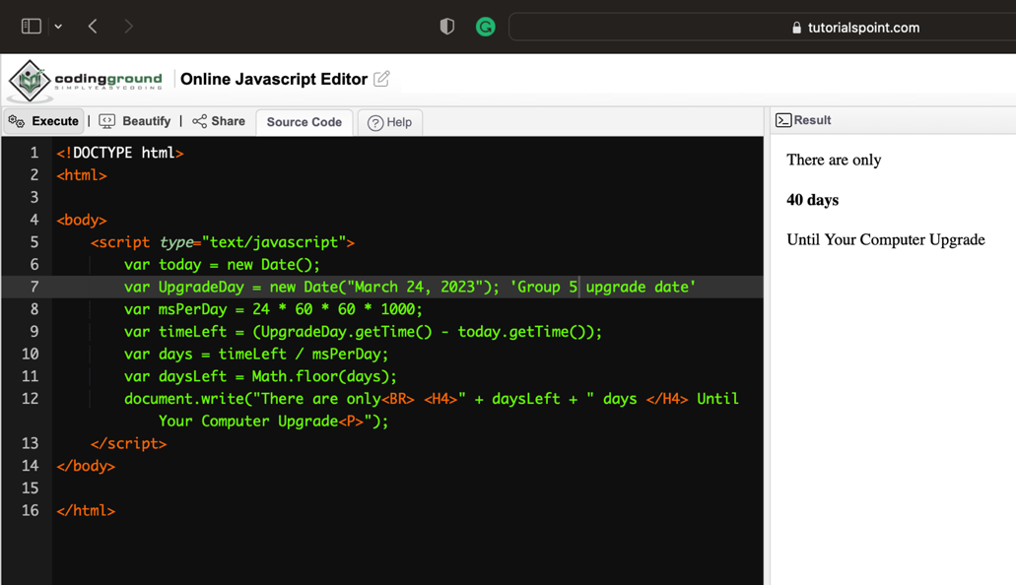

**Code: Description**

The declaration of the document type is in the tag <!DOCTYPE html>. It details the HTML version that was applied to the document. The root element of an HTML document is the tag "html." The content of an HTML document that is shown in the browser window is contained in the <body> tag (W3schools, n.d.). The script element contains the JavaScript code for the computation and result display, <script type="text/javascript"> is how the script element is defined within JavaScript. Moreover, To hold the values needed for the calculation, this code uses several variables. Declaring a variable in JavaScript is done with the keyword ‘var’. A variable is a specific term for a place in memory where data can be stored (MDN, 2023). The factors are as follows: ‘var today’, which is where the current time and date are saved. The Date and time of the computer upgrade are stored in ‘var UpgradeDay’, ‘var msPerDay’ then keeps track of how many milliseconds are in a day, ‘var timeLeft’ is the command that saves the discrepancy between the time and date of the computer update and the current time, ‘var days’ saves the outcome of dividing timeLeft by ‘var.

**Network Configuration: Explanation**

Network configuration refers to the act of configuring a network's controls, flow, and operation to support an organization's and/or network owner's network communication. This wide-ranging phrase includes an array of configuration and setup activities on network hardware, software, and other supporting devices and components. Network configuration is also known as network setup (Technopedia, 2023). The hardware and software are arranged in a specific manner based on the plan shown, so that optimum effectiveness may be gained through the network. As shown below, the organization's network setup is made up of hardware and software, with the hardware serving as the network's frame. The network setup at this organization is a server-based network that may be utilized locally or in any location that uses a client-server setup.

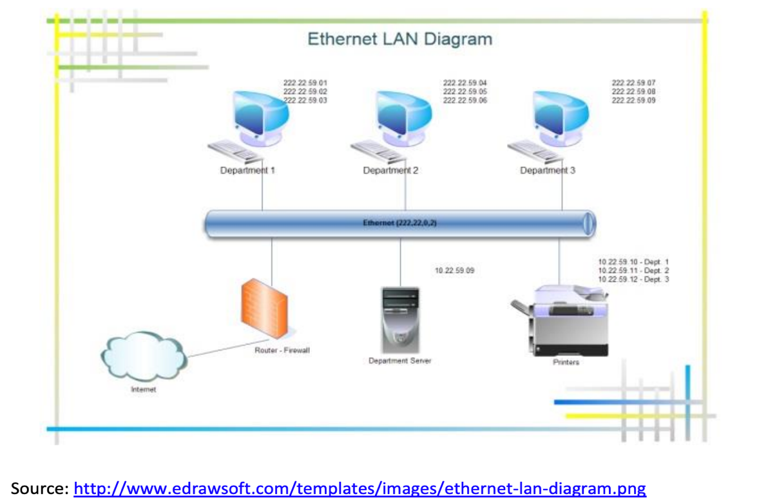

**Network Configuration: Evaluation**

**Server**

In the diagram shown above, a specialized computer known as a server performs network duties such as authenticating users, storing files, managing printers, and executing applications such as database and e-mail programs within the server-based network. Security is often centralized in a security provider, allowing users to utilize a single user account to log in to any machine on the network for which they are credentialed or authenticated. Files can be effortlessly safeguarded and backed up because they are kept centrally. Server-based networks are more expensive and difficult to set up and manage than peer-to-peer networks, and they frequently necessitate the services of a full-time network administrator. They are appropriate for enterprises with more than ten PCs that are worried about security and file integrity (Network Encyclopedia, 2019).

**Internet/Cloud**

Typically defined, the cloud is the Internet. More specifically, whatever you can access remotely over the Internet. When anything is in the cloud, it is saved on Internet servers rather than your computer's hard disk or server. Convenience and dependability are two of the key reasons why a business or individual would choose to use the cloud. Some of the most prominent reasons for using the cloud are that it allows you to store various forms of information, including files and email. This means you can use any computer or mobile device with an Internet connection to access these items. The cloud makes it simple to exchange files with several individuals at once. You may also use the cloud to keep your files safe (Internet Basics, n.d.).

**Router/Firewall**

The router-firewall, as depicted above, is a device that performs both router and firewall tasks. It not only directs data between network devices and to the internet, but it also includes security capabilities to safeguard the network from unwanted access and harmful assaults. The firewall is a security instrument that monitors and regulates incoming and outgoing network traffic according to predefined security rules, such as permitting or blocking specified categories of data or traffic from specific sources (Koons, 2023).

**Ethernet**

Ethernet is a networking technology that consists of the protocol, port, cable, and computer chip required to connect a desktop or laptop computer to a local area network (LAN) or for fast data transmission through coaxial or fiber optic cables (Breeden, 2022). Moreover, ethernet is a technology that allows computers, from servers to laptops, to communicate with each other across wired networks that employ equipment such as routers, switches, and hubs to direct traffic. Ethernet is also compatible with wireless protocols. Furthermore, Its capacity to function effectively in any setting has led to its success. This is especially true since it enables businesses to utilize the same Ethernet protocol in both their LAN and their wide-area network (WAN) (Breeden, 2022).

**Printers**

As represented in the diagram above, each department has its own network printer. A network printer is a printer that is part of a workgroup or network of computers that may all access the same printer at the same time. A network printer is not required to be physically connected to the network. Instead, it may be wirelessly linked and allocated to a workgroup. With a single printer, network printers efficiently satisfy the demands of several employees. A network printer is identified on the network by three variables: its IP address, its name, and its hardware. Any of these will efficiently transmit the location of the print device on the network. There is an abundance of benefits to having a network printer setup such as cost-savings and less required maintenance (Larkin, 2020).

**Modem**

A modem is a device that connects two networks, your local area network (LAN) and the network of your internet service provider. It functions as a local shipping and receiving facility. The name "modem" is an abbreviation for Modulator and Demodulator, which is exactly what a modem accomplishes. To transport data to and from your provider's internet network, modulation superimposes a digital wave atop an analog radio frequency (RF) carrier wave. Demodulation works in reverse, separating the RF carrier wave from the digital data that may be used by your home network. A modem is required to send and receive data from two networking paths, your internet provider's connection and your home or business network's connection (Parrish, 2022).

**Network Switch**

A network switch is a piece of hardware that allows two or more computing devices, such as computers, to connect with one another. A network switch permits people to connect to applications and equipment across a network, allowing them to interact and share resources. The most basic network switches only connect devices on a single local-area network (LAN). More sophisticated switches may link devices from different LANs and may even have rudimentary data security measures. Devices link to networks in three ways, radio waves such as Wi-Fi, electrical, such as Ethernet, and light-based optics. Each connection technique employs a distinct method of physical network connections, such as RF spectrum, copper cable, and fiber-optic cabling. These pieces of information are sent as 1s and 0s and can be translated as packets by network standards. Furthermore, these packets of information are made up of a header and a payload. Packet headers can include a variety of information such as the source and destination address of the devices involved in this connection. Payloads hold the information that networked devices are attempting to share. A network device has one or more addresses to which packets can be addressed (Juniper Network, n.d.).

**Network Configuration: Enterprise Considerations**

Prior to beginning any update process, ensure that you and your team have developed a well-thought-out strategy. Create a backup that is completely functioning and restore it in a different setting. It is always a good idea to deploy new technology on a different server, recover and transfer data, and move IP addresses. Technology updates are essential to the success of any organization. Establishing a structure to guarantee that this process runs well, weigh alternatives and choose the one that best meets your company's requirements. Next, do a limited set of tests to analyze the hazards. Finally, ensuring that your existing labor is upskilled to adapt to modern systems. The most effective strategy to modernize existing technology systems without risking data loss is to choose solutions that are simple to adopt and provide control over how data is accessed. These features will swiftly assure security and increase data access without needing businesses to give up visibility or control. Then, roll out at once or in phases. Moreover, large infrastructure and system improvements that are poorly planned and lack a clear design can result in unforeseen consequences. The most important thing to remember while planning is to follow the data stream and discover the entangled connections to minimize bottlenecks ahead of time. A "cut and paste" technological upgrade offers minimal benefit. Most technologies can coexist and be evaluated for a period of time before adopting major changes, thanks to more open systems and an availability of application program interfaces. Restating, process by process, team by team is also a good decision (Forbes.com, 2020).

**Database: Examination**

While reviewing the database in Microsoft Access, we must first check that the structure of each table, including the field names and data types, is consistent and logical. It is also critical to evaluate the quality of the data in each table and look for discrepancies or inaccuracies. In this case, within the upgrade information table, the upgrade date for each group must be entered. To accomplish this, we must open the table in its normal view, locate the upgrade date column, and enter the proper date for each group. Once we have made the required modifications, save the data and exit the table.

**Database: Modification**

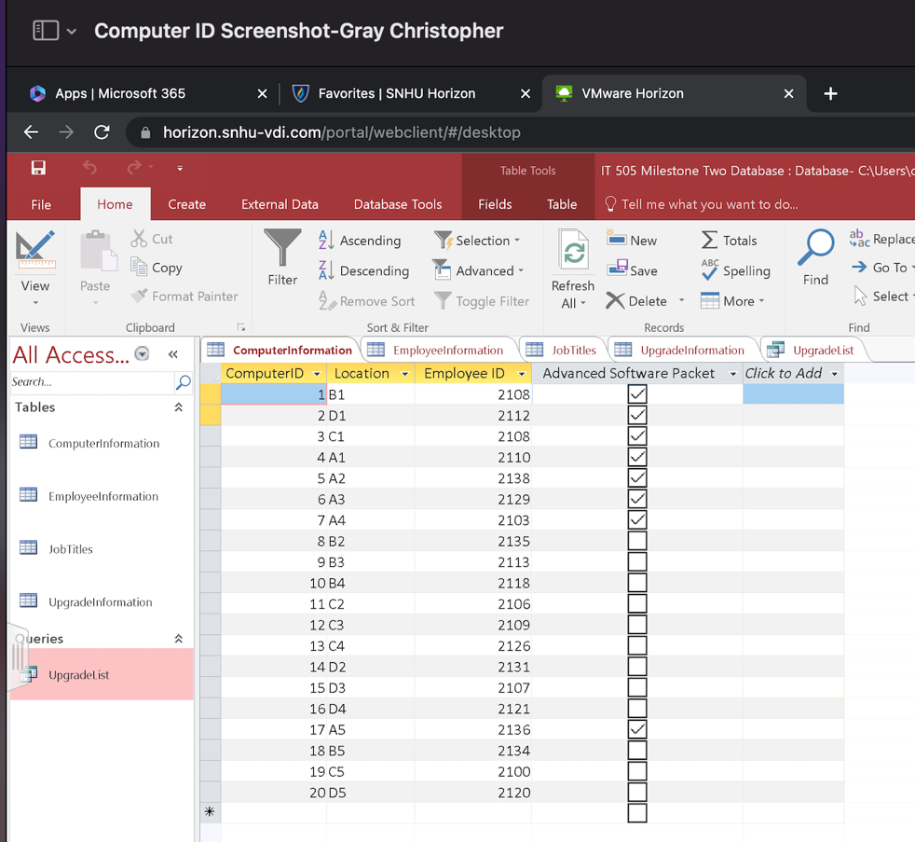

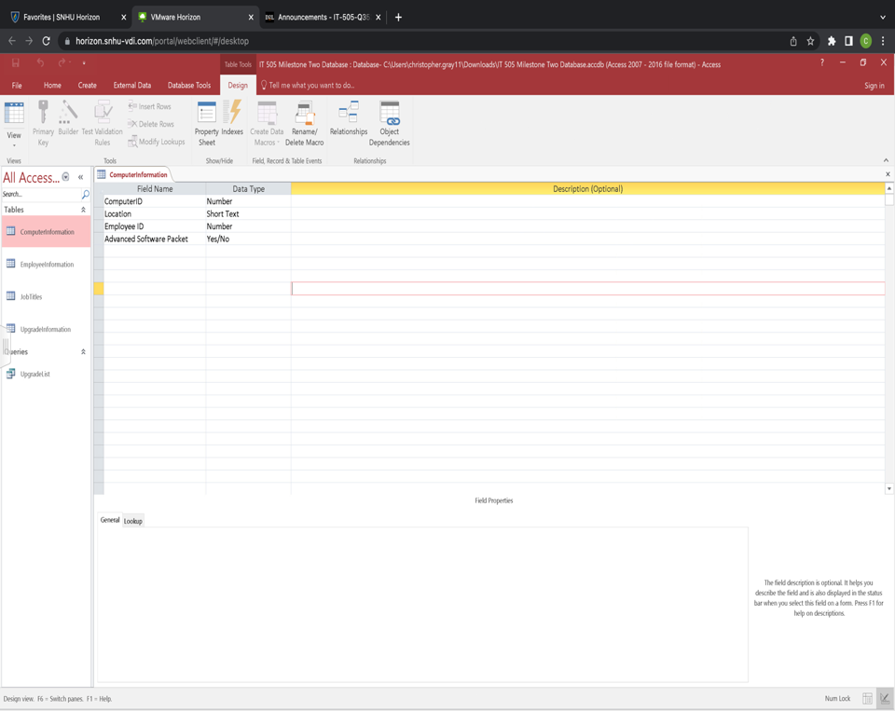

When the view is switched over from default view to the design view, the field name corresponds to the data type, as shown above, as well as the designation of advanced software packet with the option of (yes/no).

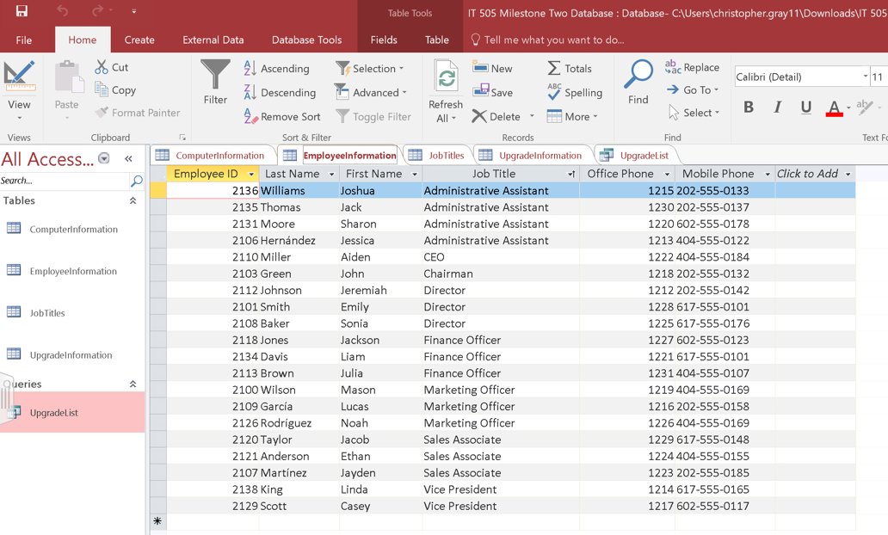

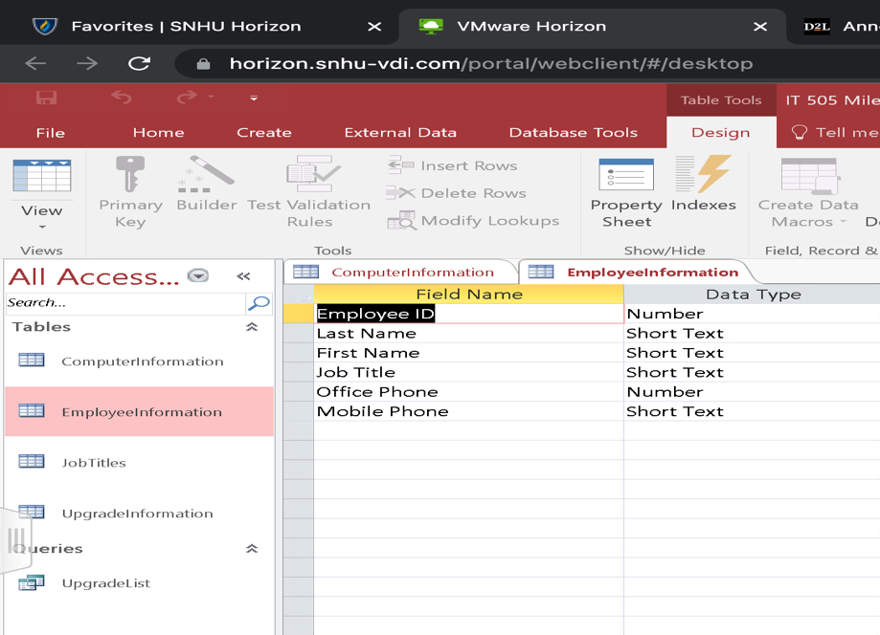

Next, we have the employee information table, this table shows the employee’s ID #, First name, job title and phone number. When switched to design view, we see the field names and the data type that is output, whether number or short text.

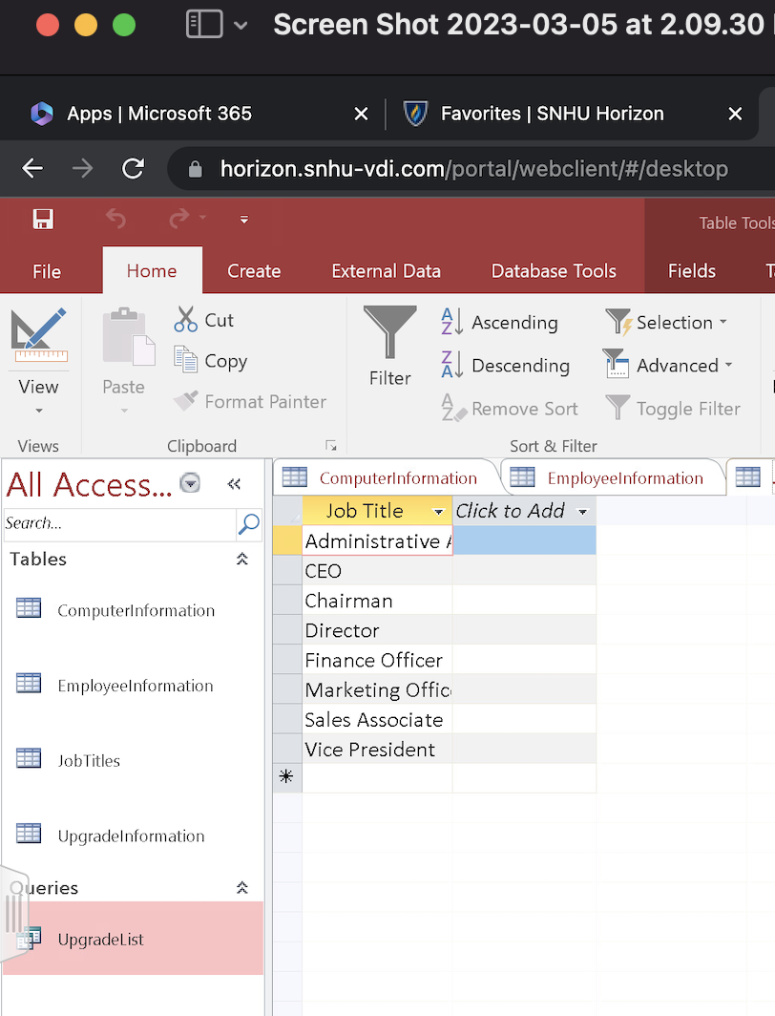

In the default view we are able to see the job titles, which switched to design view we see the field name and the data type of short text.

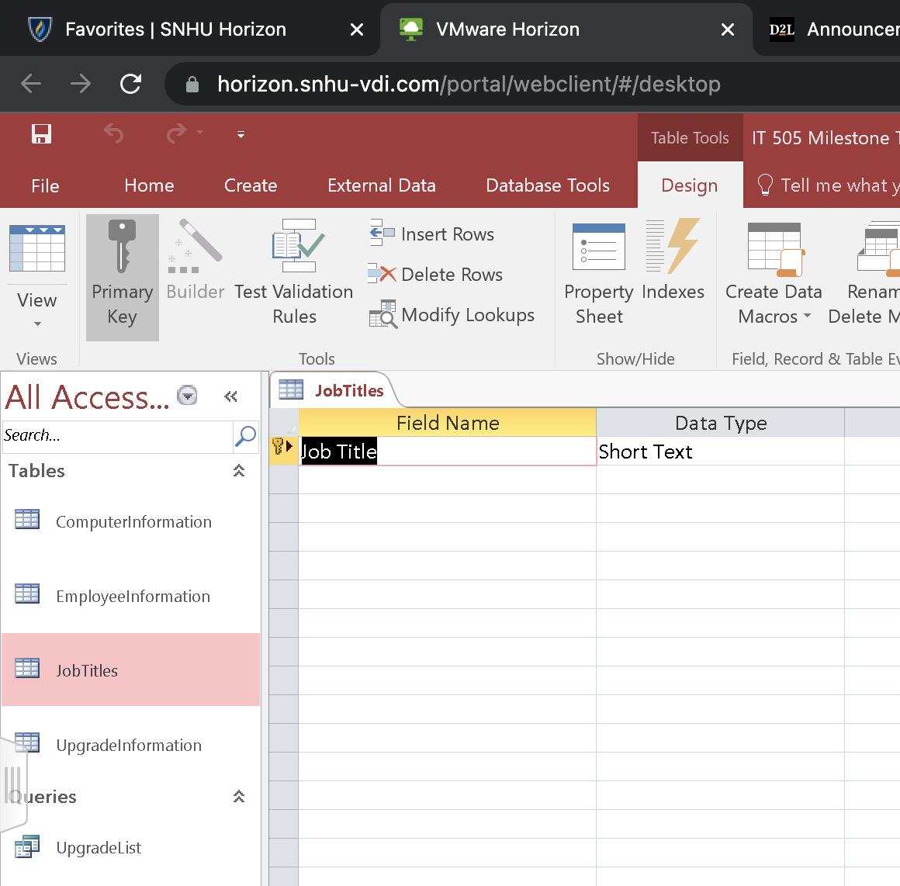

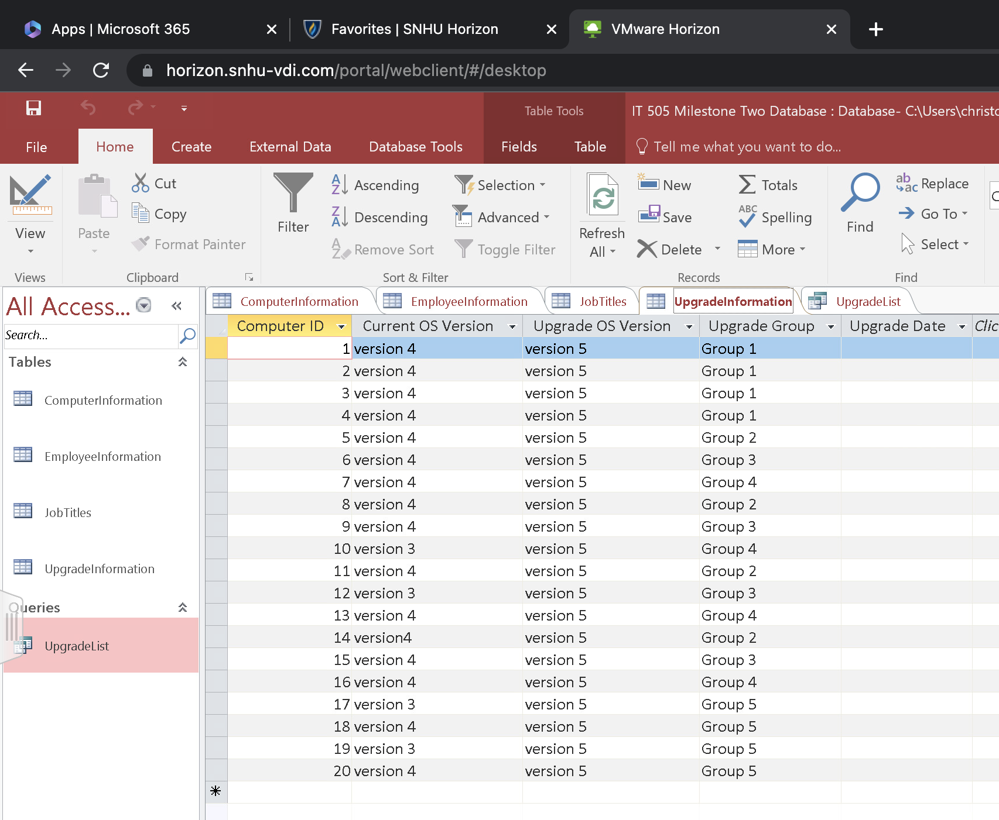

When looking at the upgrade information table we are able to see the current operating system version, the upgrade that is anticipated, and the group number that is assigned as indicated above. We are also able to see the field name and data type as indicated below when we switch to design view.

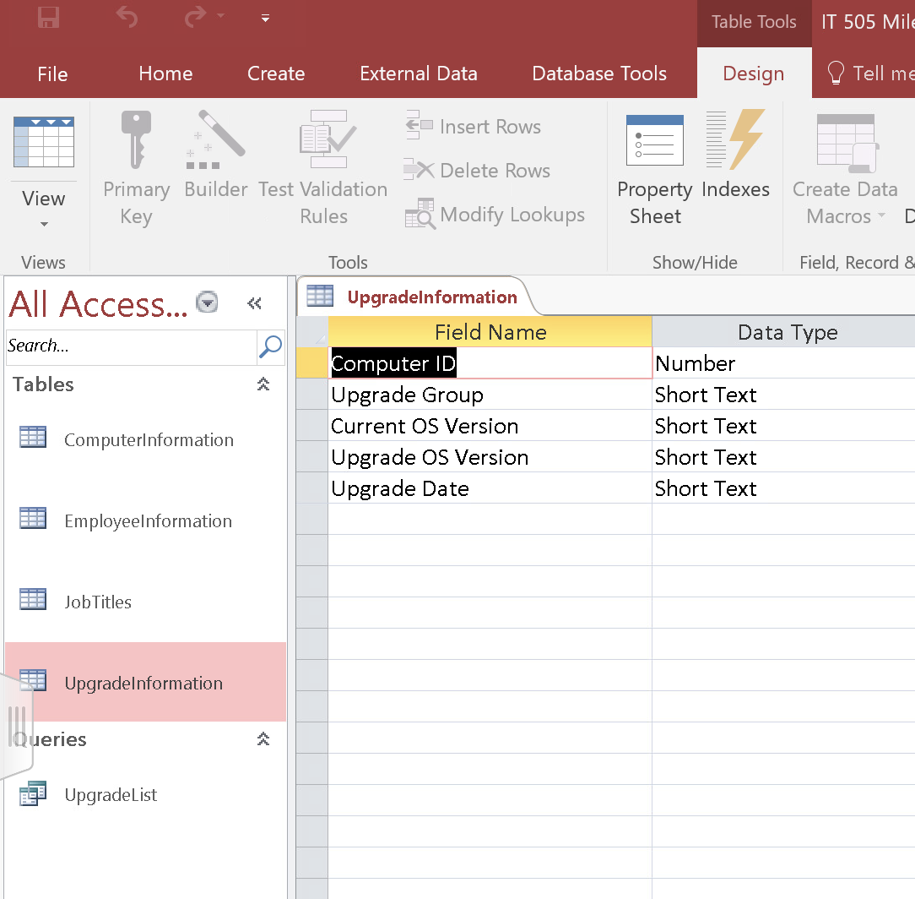

When viewing the upgrade information table in design view we want to next insert the upgrade date.

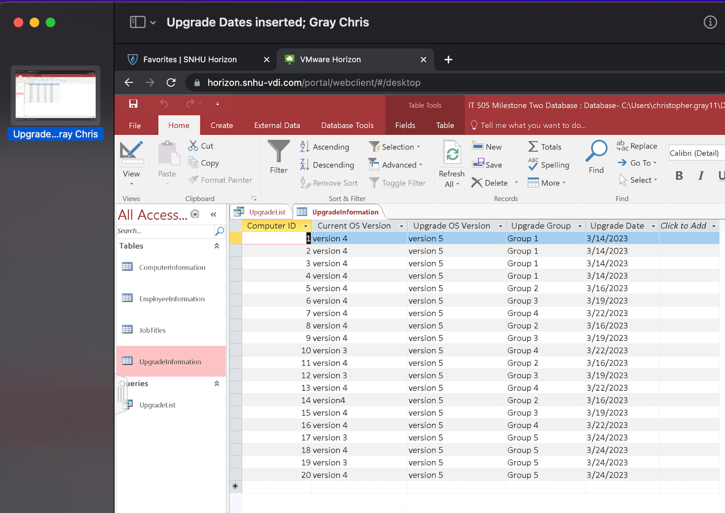

To insert the correct date:

* Open the information table in default view.
* Find the upgrade date column, place the cursor in the appropriate blank empty cell.
* Insert the date according to the upgrade group.
* Save the data and close the table.

**Database: Query**

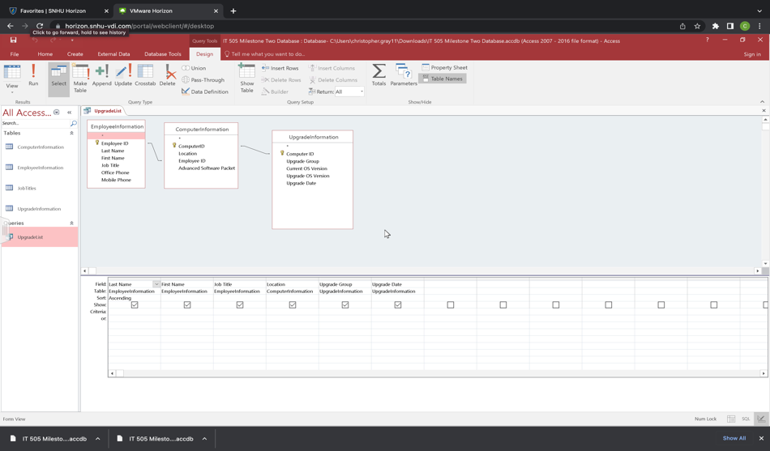

Above is the query table. The tables are connected by primary keys. The employee ID and Computer ID are connected and will be used to determine which system update will occur on which date. Furthermore, we will need to establish which employee will be receiving their upgrades based on their employee ID. In order to make this happen we will click the exclamation point under the design view tab.

Here is the result of the query being ran:

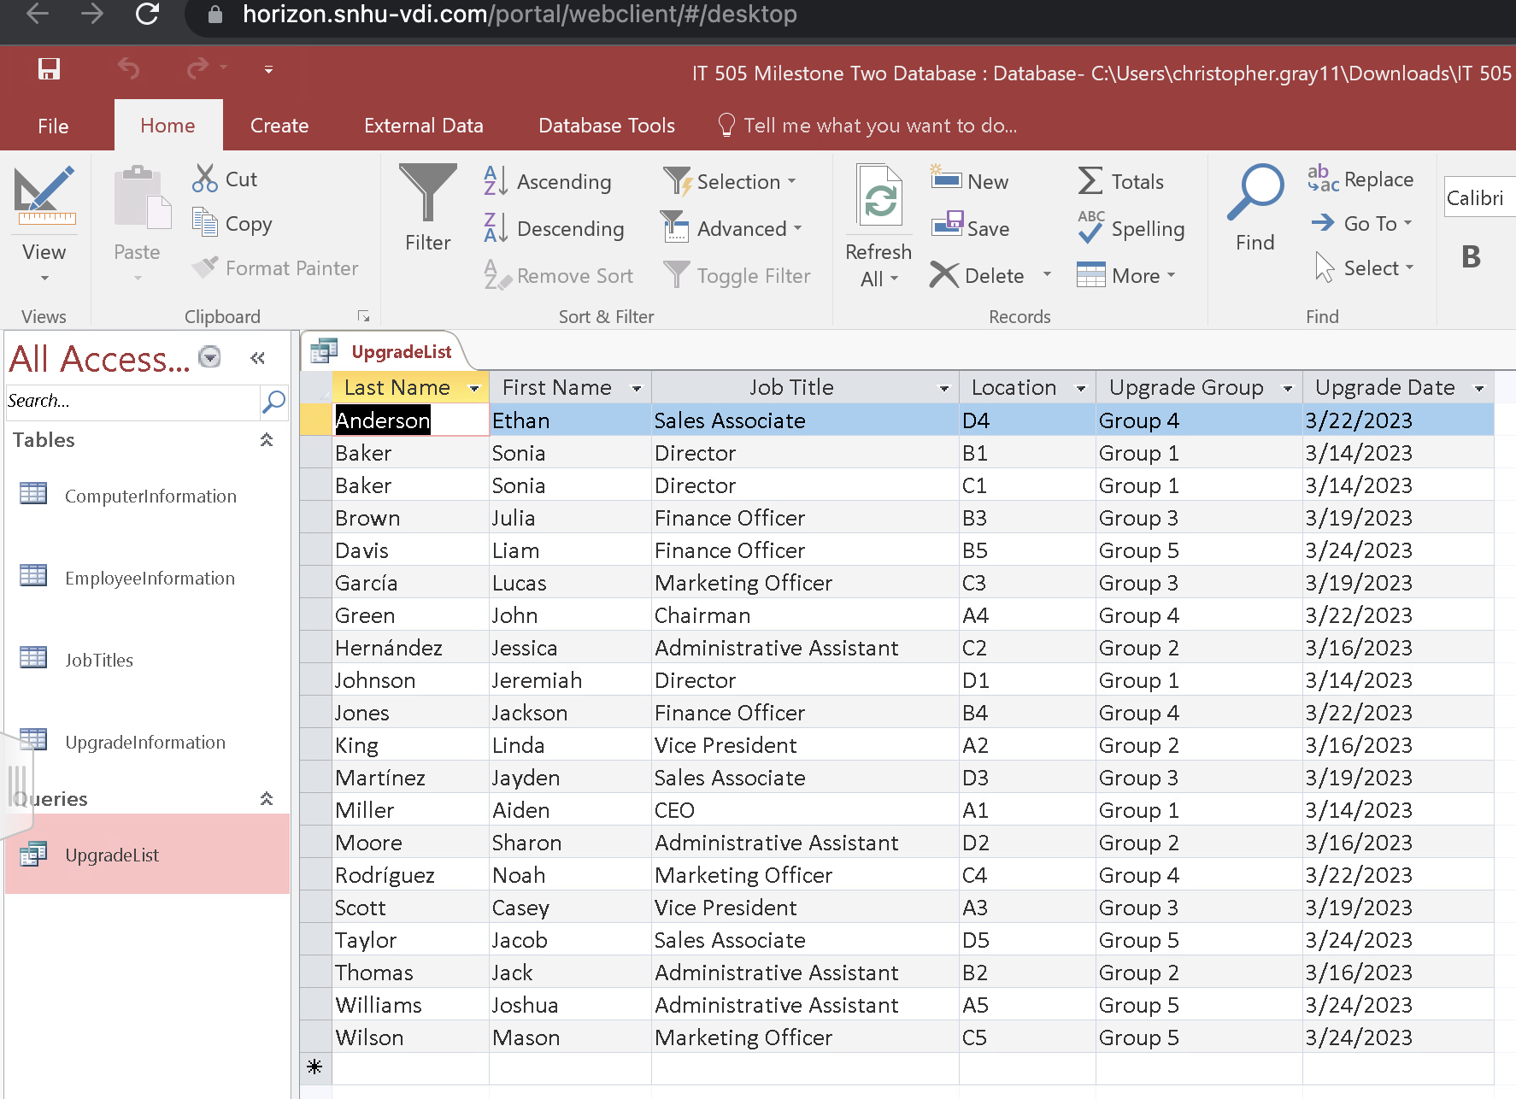

**Presentation: Description**

**This portion will be sent as an attachment**

**Presentation: Risks**

**This portion will be sent as an attachment**

**Presentation: Countermeasures**

**This portion will be sent as an attachment**

**Tutorials: Homepage**

A web browser is software that allows you to search for and view webpages on the Internet. There are several web browsers available, but some of the most popular include Google Chrome, Safari, and Mozilla Firefox. Whichever online browser you use, you should grasp the fundamentals of web browsing (GCFglobal.org, n.d.). In this session, we will go through how to establish your homepage. In tutorial number two we will enable cookies to improve your user experience.

Setting the organization website as the homepage in Google Chrome:

1. Open the Google Chrome browser.
2. In the top right corner of the chrome browser, click the  button and select Settings from the list.
3. Locate the **Appearance** setting in the **Settings** menu. There is a checkbox titled **Show Home Button** beneath it. If this option is marked, the homepage's web URL will be shown (Support.google.com, n.d.).
4. select Change to edit the web address of the homepage and manually type in or use copy & paste for the address that you would like. 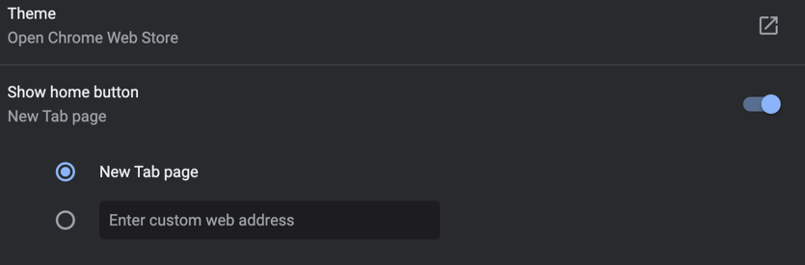
5. The task of setting a homepage is complete!

**Tutorials: Cookies**

1. Open the Google Chrome browser.
2. In the top right portion of the screen, click the Settings icon .
3. Under "Privacy and security," click Site settings. 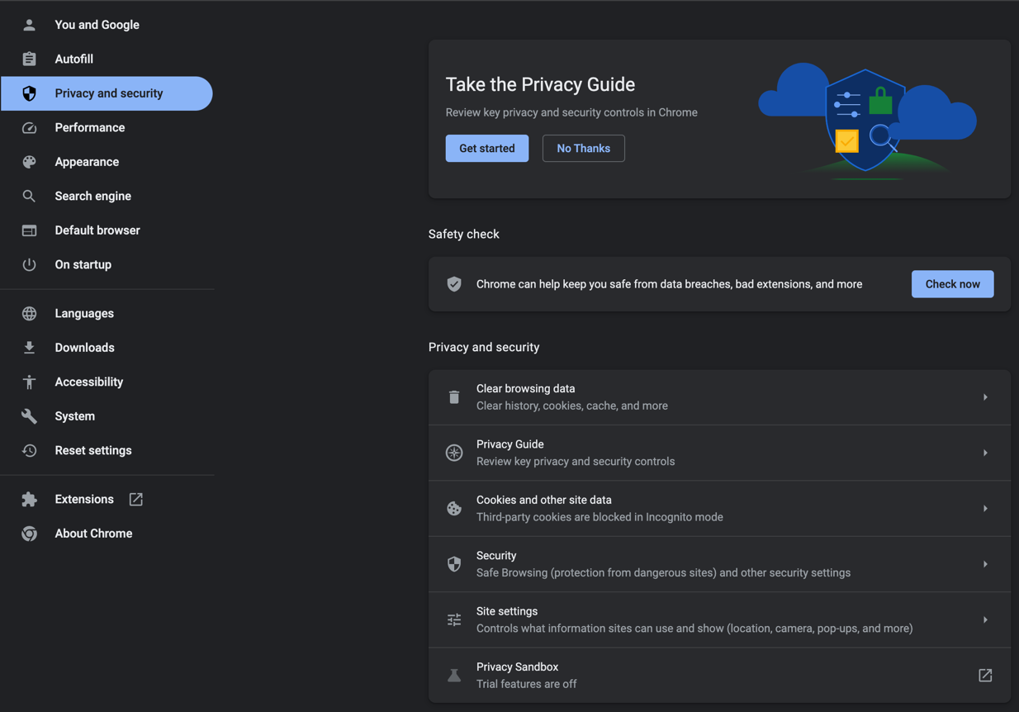
4. Click on Cookies and site data button. 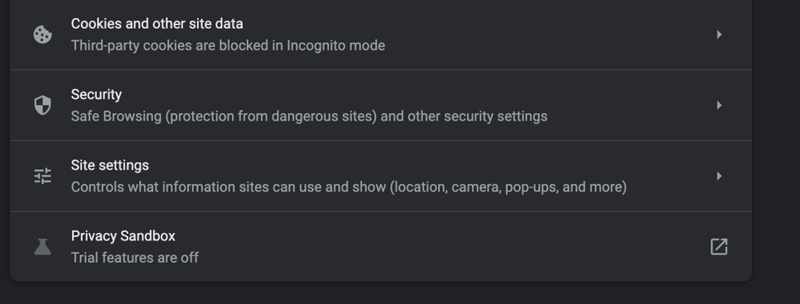
5. From this area you are able to turn cookies on or turn them off (support.google.com, n.d.).

References

Breeden, J., II (2022, April 18). *What is Ethernet?* Https://www.Networkworld.com. Retrieved March 3, 2023, from [https://www.networkworld.com/article/3657734/what-is-](https://www.networkworld.com/article/3657734/what-is-ethernet.html#:~:text=Ethernet%20works%20by%20breaking%20up,its%20way%20through%20a%20network)ethernet.html#:~:text=Ethernet%20works%20by%20breaking%20up,its%20way%20through%20a%20network.

Editors, F. T. C. (2020, April 16). *Council post: 16 best practices for safely upgrading your company's Tech Systems*. Forbes. Retrieved April 2, 2023, from https://www.forbes.com/sites/forbestechcouncil/2020/04/16/16-best-practices-for-safely-upgrading-your-companys-tech-systems/?sh=7be25ca8239e

High-level programming language - MDN Web Docs Glossary: Definitions of Web-related terms | MDN. (2023). Retrieved 8 February 2023, from <https://developer.mozilla.org/en-US/docs/Glossary/High-level_programming_language>

HTML Reference. (2023). Retrieved 11 February 2023, from <https://www.w3schools.com/tags/default.asp>

#### Internet Basics: Using a Web Browser. (n.d.). Retrieved 16 March 2023, from https://edu.gcfglobal.org/en/internetbasics/using-a-web-browser/1/

JavaScript | MDN. (2022). Retrieved 8 February 2023, from <https://developer.mozilla.org/en-US/docs/Web/JavaScript>

jQuery. (n.d.). jQuery - The Write Less, Do More, JavaScript Library. Retrieved from [https://jquery.com](https://jquery.com/)/

Koons, K. (2023, February 24). *What is a Router Firewall?* Https://www.Easytechjunkie.com. Retrieved March 2, 2023, from [https://www.easytechjunkie.](https://www.easytechjunkie.com/what-is-a-router-firewall.htm)com/what-is-a-router-firewall.htm

Internet Basics: Understanding the Cloud. (2023). Retrieved 4 March 2023, from https://edu.gcfglobal.org/en/internetbasics/understanding-the-cloud/1/#

Larkin, D. (2020, April 6). *Local vs Network Printers and How Your Business Can Benefit*. Www.Marconet.com. Retrieved March 4, 2023, from /blog/local-vs-network-printers-and-how-your-business-can-benefit#:~:text=A%20network%20printer%20can%20accommodate,to%20print%20from%20remote%20locations.

Math.floor() - JavaScript | MDN. (2022). Retrieved 11 February 2023, from https://developer.mozilla.org/en-US/docs/Web/JavaScript/Reference/Global_Objects/Math/floor

Mozilla Developer Network (MDN) Web Docs. (n.d.). Variables. Retrieved from <https://developer.mozilla.org/en-US/docs/Learn/JavaScript/First_steps/Variables>

Network Switch Symbol - Free Transparent PNG Clipart Images Download. ClipartMax.com. (2023). Retrieved 4 March 2023, from https://www.clipartmax.com/middle/m2H7d3m2Z5G6G6b1_network-switch-symbol/

Parrish, K. (2022, August 1). *What Is a Modem and Why You Need One to Get Internet*. Www.Highspeedinternet.com. Retrieved March 4, 2023, from /resources/what-is-a-modem#:~:text=A%20modem%20is%20a%20device,to%20send%20and%20receive%20data.

Server-based Network - Network Encyclopedia. (2019). Retrieved 2 March 2023, from <https://networkencyclopedia.com/server-based-network/>

#### Turn cookies on or off - Computer - Google Account Help. (2023). Retrieved 16 March 2023, from https://support.google.com/accounts/answer/61416

What is Network Configuration? - Definition from Techopedia. (2023). Retrieved 1 March 2023, from <https://www.techopedia.com/definition/25766/network-configuration>

What is a network switch? | Juniper Networks US. (n.d.). Retrieved 4 March 2023, from [https://www.juniper.net/us/en/research-topics/what-is-a-network-](https://www.juniper.net/us/en/research-topics/what-is-a-network-switch.html#:~:text=A%20network%20switch%20connects%20users,%2Darea%20network%20(LAN))switch.html#:~:text=A%20network%20switch%20connects%20users,%2Darea%20network%20(LAN).

Wireless router. Modem with wifi signal. Wi-fi signal symbol. Internet Connection. Wi-fi wireless technology illustration on isolated background. Vector illustration Stock Vector. (2023). Retrieved 4 March 2023, from https://stock.adobe.com/images/wireless-router-modem-with-wifi-signal-wi-fi-signal-symbol-internet-connection-wi-fi-wireless-technology-illustration-on-isolated-background-vector-ilustration/342406452.

W3Schools. (n.d.). JavaScript Variables. Retrieved from <https://www.w3schools.com/js/js_variables.asp>

W3Schools. (n.d.). JavaScript Data Structures. Retrieved from <https://www.w3schools.com/js/js_datastructures.asp>

W3Schools. (n.d.). JavaScript Control Structures. Retrieved from <https://www.w3schools.com/js/js_if_else.asp>

W3Schools. (n.d.). JavaScript Syntax. Retrieved from <https://www.w3schools.com/js/js_syntax.asp>